****

****

**Report Maintenance**

**Periode #11 Bulan Januari 2019**

**<periode continue> dan <Bulan mengikuti jadwal PM>**

**Pekerjaan :**

**Perpanjangan Garansi & Maintenance SAN Storage**

****

**SATUAN KERJA KHUSUS PELAKSANA KEGIATAN   
USAHA HULU MINYAK DAN GAS BUMI   
(SKK MIGAS)**

**PT DELTADATA MANDIRI**

**Gandaria 8 Office Tower, Lt. 8 . Jl. Iskandar Muda, Arteri Pondok Indah, Jakarta 12240**

**Phone : +62 21 2985 1622, Fax : +62 21 29851601, Email :** [**support@deltadatamandiri.com**](mailto:support@deltadatamandiri.com)**, website : www.deltadatamandiri.com**

**Lembar Pengesahan**

|  |  |
| --- | --- |
| **PT. Deltadata Mandiri** | |
| 1.  ……………………………………….. | 2.  ……………………………………….. |
| **SKK Migas** | |
| 1.  ……………………………………….. | 2.  ……………………………………….. |

DAFTAR ISI

[Topologi DC Jakarta 4](#_Toc536017240)

[Topologi DRC Jatiluhur 5](#_Toc536017241)

[BAB 1. Pendahuluan 6](#_Toc536017242)

[BAB 2. Lingkup Pekerjaan 7](#_Toc536017243)

[BAB 3. Preventive Maintenance 9](#_Toc536017244)

[3.1 Jadwal Preventive Maintenance 9](#_Toc536017245)

[3.2 Pelaksanaan Preventive Maintenance 10](#_Toc536017246)

[3.2.1 Daftar Perangkat 10](#_Toc536017247)

[3.2.2 Aktifitas Engineer Onsite Deltadata Mandiri 11](#_Toc536017248)

[3.3 Health Check 12](#_Toc536017249)

[3.3.1 Netapp FAS8040HA JKT-STOCL ( DC Jakarta ) 12](#_Toc536017250)

[3.3.2 Netapp FAS8020 HA JAH-STOCL ( DRC Jatiluhur ) 42](#_Toc536017251)

[3.4 Kesimpulan dan Saran 54](#_Toc536017252)

[3.4.1 Kesimpulan 54](#_Toc536017253)

[3.4.2 Saran 54](#_Toc536017254)

[BAB 4. Corrective Maintenance 55](#_Toc536017255)

[4.1 Activity Report 55](#_Toc536017256)

[BAB 5. Penggantian Part 56](#_Toc536017257)

[BAB 6. Penutup 57](#_Toc536017258)

# Topologi DC Jakarta

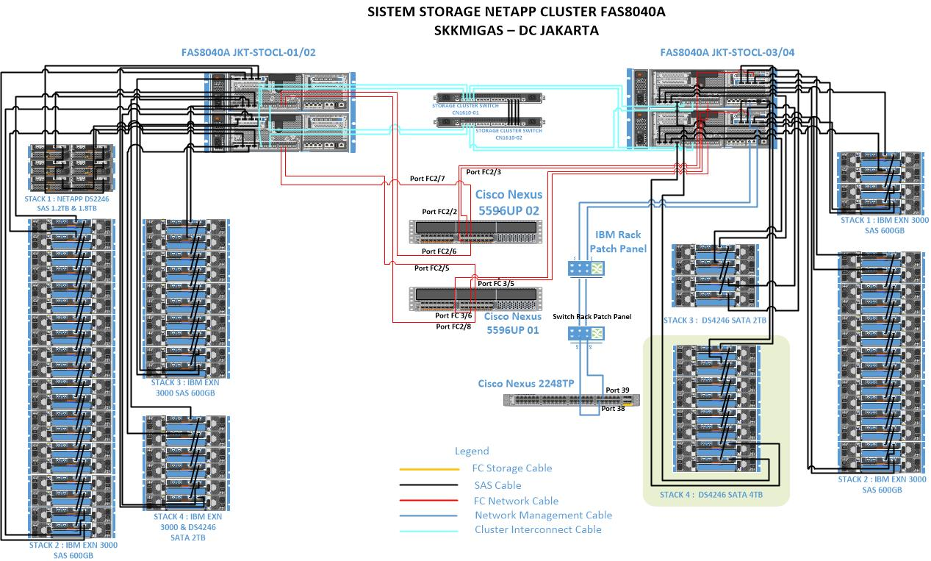

# Topologi Storage SKK_DRCTopologi DRC Jatiluhur

# Pendahuluan

Berdasarkan Nomor : PJN-0023/SMPPK1000/2018/S7 tanggal 2 Maret 2018 pihak SKK MIGAS telah menandatangani kesepakatan Perpanjangan Pengadaan Garansi dan Maintenance Perangkat Storage TI SKK MIGAS dengan PT. Deltadata Mandiri. Job description untuk maintenance meliputi perbaikan perangkat storage dan perawatan secara berkala setiap bulan. Dengan jangka waktu maintenance selama 12 bulan terhitung dari *5 Maret 2018 — 04 April 2019.*

Kami mengharapkan semoga laporan beserta dokumentasi ini dapat digunakan sebagai bahan analisa dan monitoring untuk mengontrol kegiatan operasional di SKK MIGAS.

Akhir kata kami ucapkan terimakasih kepada pihak manajemen SKK MIGAS yang telah memberikan kepercayaan kepada PT. Deltadata Mandiri sebagai partner support maintenance storage.

# Lingkup Pekerjaan

Sebelum menjelaskan aktifitas-aktifitas yang dilakukan dalam pelaksanaan pekerjaan Perpanjangan Garansi dan Maintenance Perangkat SAN Storage SKK Migas, terlebih dahulu akan disampaikan kembali lingkup dari pekerjaan ini secara menyeluruh. Hal ini dimaksudkan agar pekerjaan yang telah dilakukan sejalan dengan lingkup pekerjaan ini.

Lingkup dan Uraian pekerjaan yang menjadi tanggung jawab PT Deltadata Mandiri dalam menyediakan service pelayanan adalah sebagai berikut :

1. Perpanjangan garansi dan/atau subscription atas perangkat-perangkat yang berikut ini.

|  |  |  |  |  |
| --- | --- | --- | --- | --- |
| **No** | **Serial Number** | **Description** | **Qty** | **Lokasi** |
| 1 | 451622000092 | NetApp FAS8040 | 1 | Kantor Pusat Jakarta |
|  | 451622000091 |
| 2 | 451622000090 | NetApp FAS8040 | 1 |
|  | 451622000089 |
| 3 | 451613000031 | NetApp FAS8020 | 1 | DRC Jatiluhur |
|  | 451613000032 |

1. Pelaksanaan kegiatan maintenance yang terdiri atas preventif dan corrective, termasuk diantaranya adalah :

* Melakukan kegiatan preventif maintenance secara on-site dikantor pusat dan remote untuk kantor perwakilan secara berkala minimal 1 (satu) kali perbulan untuk memastikan kondisi seluruh perangkat dalam keadaan baik dan beroperasi dengan normal.
* Melakukan troubleshooting atas permasalahan yang terjadi via telepon, email ataupun on-site visit apabila diperlukan dan sesuai dengan SLA 24x7x4; Coverage 24 jam 7 hari seminggu dengan respon time maksimal 1 jam dan resolution time maksimal 4 jam termasuk apabila perlu dilakukan penggantian perangkat.
* Menyediakan perangkat pengganti sementara apabila terjadi kerusakan pada perangkat keras ataupun lunak hingga selesai diperbaiki / diganti.
* Melakukan konfigurasi ulang atas perangkat jaringan yang telah selesai diperbaiki / diganti sehingga dapat beroperasional kembali dengan baik.

1. Menyediakan Helpdesk Support sebagai time skalasi tingkat 1 dalam menangani setiap permasalahan yang terjadi.
2. Membantu proses eskalasi kepihak principal/distributor apabila tidak dapat ditangani oleh penyedia jasa.
3. Melakukan review kondisi dan status perangkat storage secara berkala minimal 2 (dua) kali selama masa maintenance.
4. Pembuatan laporan secara tertulis hasil kegiatan preventif dan corrective maintenance termasuk didalamnya permasalahan yang terjadi, penyebab permasalahan, solusi yang dilaksanakan dan saran untuk selanjutnya.
5. Pembuatan dokumentasi awal dan akhir serta backup lengkap konfigurasi perangkat storage aktif 1 bulan sebelum masa kontrak maintenance berakhir.

# Preventive Maintenance

## Jadwal Preventive Maintenance

Berikut adalah jadwal Pelaksanaan Pekerjaan Maintenance dan Garansi Perangkat Storage dilaksanakan selama 12 (dua belas) bulan terhitung dari *05 Maret 2018 —04 Maret 2019*

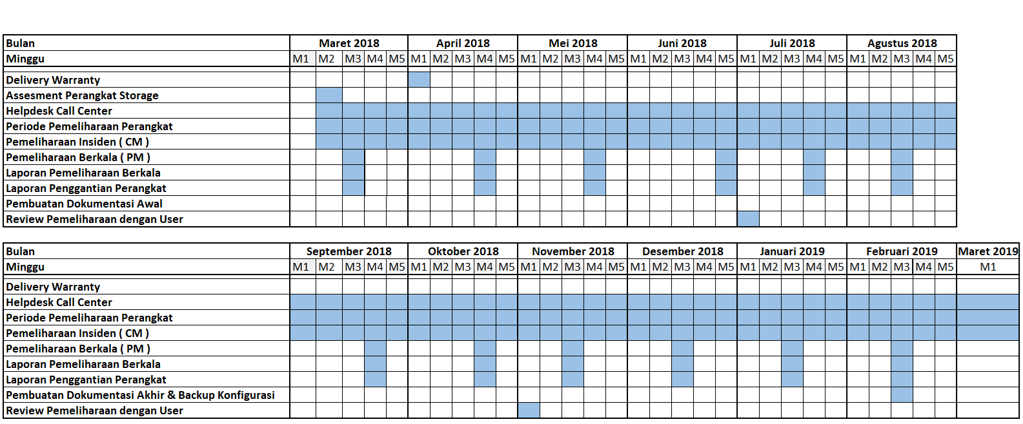

## Pelaksanaan Preventive Maintenance

### Daftar Perangkat

Berikut adalah daftar perangkat storage yang akan dilakukan Preventive Maintenance :

|  |  |  |  |  |  |  |
| --- | --- | --- | --- | --- | --- | --- |
| **No** | **Hostname** | **Serial Number** | **Model** | **Ontap Version** | **Qty** | **Lokasi** |
| 1 | JKT-STOCL-01 | 451622000092 | FAS8040 | 8.3.2P3 C-Mode | 1 | DC Jakarta |
| JKT-STOCL-02 | 451622000091 | FAS8040 | 8.3.2P3 C-Mode | 1 |
| DS4243 |  |  |  | 17 |
| DS4246 |  |  |  | 4 |
| DS2246 |  |  |  | 4 |
|  |  |  |  |  |  |  |
| 2 | JKT-STOCL03 | 451622000090 | FAS8040 | 8.2.3P3 C-Mode | 1 | DC Jakarta |
| JKT-STOCL04 | 451622000089 | FAS8040 | 8.2.3P3 C-Mode | 1 |
| DS4243 |  |  |  | 10 |
| DS4246 |  |  |  | 6 |
|  |  |  |  |  |  |  |
| 3 | JAH-STOCL-01 | 451613000032 | FAS8020 | 8.2.3P3 C-Mode | 1 | DRC Jatiluhur |
| JAH-STOCL-02 | 451613000031 | FAS8020 | 8.2.3P3 C-Mode | 1 |
| DS4243 |  |  |  | 4 |
| DS4246 |  |  |  | 2 |

### Aktifitas Engineer Onsite Deltadata Mandiri

Berikut adalah aktifitas engineer Onsite Deltadata Mandiri dalam pelaksanaan Preventive Maintenance periode *#11* (Bulan Januari 2019) < periode dan bulan di sesuaikan dengan bulan maintenance>untuk lokasi di Data Center berikut :

|  |  |  |  |  |  |  |  |  |  |  |  |  |
| --- | --- | --- | --- | --- | --- | --- | --- | --- | --- | --- | --- | --- |
| **No** | **Engineer** | **User** | **M/T** | **S/N** | **Date** | **Arrival** | **Start** | **Stop** | **AC out** | **Volt  Check  out** | **Test** | **Remark** |
| 1 | Wahidi | Heru Basuki | FAS8040 | 451622000092/91 | 17 Januari 2019 | 10.30 | 10.30 | 12.00 | ok | ok |  | ok |
| 2 | Wahidi | Heru Basuki | FAS8040 | 451622000090/89 | 17 Januari 2019 | 10.30 | 10.30 | 12.00 | ok | ok |  | ok |
| 3 | Wahidi | Heru Basuki | FAS8020 | 451613000032/31 | 17 Januari 2019 | 10.30 | 10.30 | 12.00 | ok | ok |  | ok |
| 4 |  |  |  |  |  |  |  |  |  |  |  |  |
| 5 |  |  |  |  |  |  |  |  |  |  |  |  |
| 6 |  |  |  |  |  |  |  |  |  |  |  |  |
| 7 |  |  |  |  |  |  |  |  |  |  |  |  |
| 8 |  |  |  |  |  |  |  |  |  |  |  |  |
| 9 |  |  |  |  |  |  |  |  |  |  |  |  |
| 10 |  |  |  |  |  |  |  |  |  |  |  |  |

## Health Check

Berikut ini adalah rangkuman aktifitas healthy check yang telah dilakukan saat melakukan preventive maintenance di Data Center. Adapun tujuan healthy check ini adalah untuk melihat performa dari system storage & perangkat keras yang dimonitor dan menjadi bagian dari lingkup pekerjaan ini.

### Netapp FAS8040HA JKT-STOCL ( DC Jakarta )

**JKT-STOCL-01, Controller A**

Version : NetApp Release 9.1P14 Cluster Mode

Model Name : FAS8040

System Serial Number : 451622000092 (JKT-STOCL-01)

System ID : 0536996714 (JKT-STOCL-01)

Partner ID : 0536993951 (JKT-STOCL-02)

Loader Version : 5.5

Processor type : Intel(R) Xeon(R) CPU E5-2658 @ 2.10GHz

Memory Size : 32768 MB

NVRAM : 8192 MB

**JKT-STOCL-02, Controller B**

Version : NetApp Release 9.1P14 Cluster Mode

Model Name : FAS8040

System Serial Number : 451622000091 (JKT-STOCL-02)

System ID : 0536993951 (JKT-STOCL-02)

Partner ID : 0536996714 (JKT-STOCL-01)

Loader Version : 5.5

Processor type : Intel(R) Xeon(R) CPU E5-2658 @ 2.10GHz

Memory Size : 32768 MB

NVRAM : 8192 MB

**JKT-STOCL-03, Controller C**

Version : NetApp Release 9.1P14 Cluster Mode

Model Name : FAS8040

System Serial Number : 451622000090 (JKT-STOCL-03)

System ID : 0536972927 (JKT-STOCL-03)

Partner ID : 0536996505 (JKT-STOCL-04)

Loader Version : 5.5

Processor type : Intel(R) Xeon(R) CPU E5-2658 @ 2.10GHz

Memory Size : 32768 MB

NVRAM : 8192 MB

**JKT-STOCL-04, Controller D**

Version : NetApp Release 9.1P14 Cluster Mode

Model Name : FAS8040

System Serial Number : 451622000089 (JKT-STOCL-04)

System ID : 0536996505 (JKT-STOCL-04)

Partner ID : 0536972927 (JKT-STOCL-03)

Loader Version : 5.5

Processor type : Intel(R) Xeon(R) CPU E5-2658 @ 2.10GHz

Memory Size : 32768 MB

NVRAM : 8192 MB

1. **System Dashboard**

**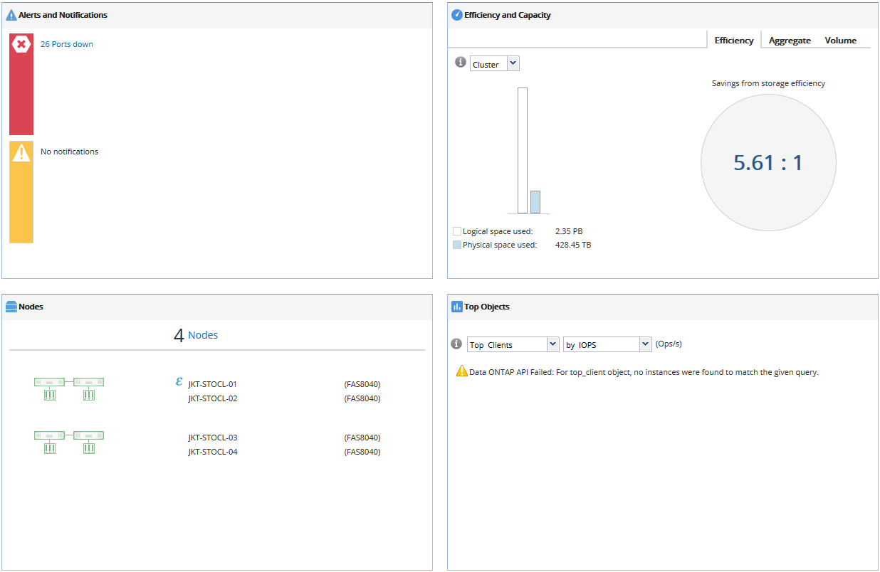**

**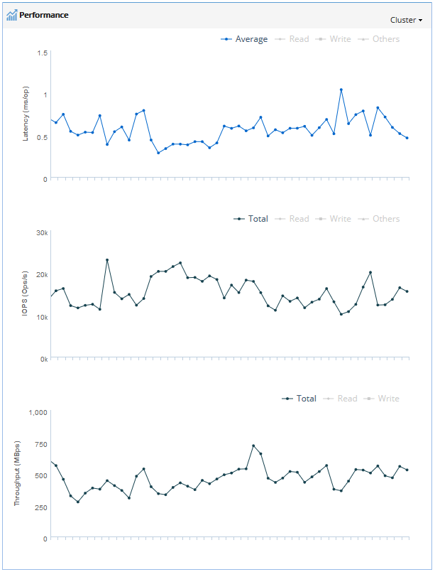**

1. **Storage Capacity**

**Table di bawah refer ke file .xls (C:\Users\WAHIDI\Documents\PM SKK\DC) SKK\_PM\_DC\_20190210102441.xls -> Sheet Hardware Overview -> NetApp System Inventory (All Storage Systems - by HA Pair)**

|  |  |  |  |  |  |  |  |
| --- | --- | --- | --- | --- | --- | --- | --- |
| **NetApp System Inventory (All Systems)** | | | |  |  |  |  |
| **Model** | **Hostname** | **Serial Number** | **OS Version** | **Total Capacity (TB)** | **Total Usable Capacity (TB)** | **Total Used Capacity (TB)** | **Total Available Capacity (TB)** |
|  |  |  |  |  |  |  |  |
|  |  |  |  |  |  |  |  |
|  |  |  |  |  |  |  |  |
|  |  |  |  |  |  |  |  |

**JKT-STOCL-01**

**Table di bawah refer ke file .xls (C:\Users\WAHIDI\Documents\PM SKK\DC) SKK\_PM\_DC\_20190210102441.xls -> Sheet Capacity -> Host Name : JKT-STOCL-01 -> Aggregate Info**

|  |  |  |  |  |  |  |  |
| --- | --- | --- | --- | --- | --- | --- | --- |
| **Aggregate Info** | | | | |  |  |  |
| **Aggregate Name** | **Allocated (TB)** | **Used (TB)** | **Avail (TB)** | **Avail (%)** | **Snap Reserve %** | **Avail in Volumes (GB)** | **Aggregate Type** |
|  |  |  |  |  |  |  |  |
|  |  |  |  |  |  |  |  |
|  |  |  |  |  |  |  |  |

**Table di bawah refer ke file .xls (C:\Users\WAHIDI\Documents\PM SKK\DC) SKK\_PM\_DC\_20190210102441.xls -> Sheet Capacity -> Host Name : JKT-STOCL-01 -> Disk Summary**

|  |  |  |  |  |  |  |
| --- | --- | --- | --- | --- | --- | --- |
| **Disk Summary** | | | | |  |  |
| **Disk Model** | **Disk Type** | **Disk Mktg Size(GB)** | **# of Owned Disks** | **# of Data Drives** | **# of Parity Drives** | **# of Spare Disks** |
|  |  |  |  |  |  |  |
|  |  |  |  |  |  |  |
|  |  |  |  |  |  |  |
|  |  |  |  |  |  |  |
|  |  |  |  |  |  |  |
|  |  |  |  |  |  |  |
|  |  |  |  |  |  |  |
|  |  |  |  |  |  |  |
|  |  |  |  |  |  |  |

**JKT-STOCL-02**

**Table di bawah refer ke file .xls (C:\Users\WAHIDI\Documents\PM SKK\DC) SKK\_PM\_DC\_20190210102441.xls -> Sheet Capacity -> Host Name : JKT-STOCL-02 -> Aggregate Info**

|  |  |  |  |  |  |  |  |
| --- | --- | --- | --- | --- | --- | --- | --- |
| **Aggregate Info** | | | | |  |  |  |
| **Aggregate Name** | **Allocated (TB)** | **Used (TB)** | **Avail (TB)** | **Avail (%)** | **Snap Reserve %** | **Avail in Volumes (GB)** | **Aggregate Type** |
|  |  |  |  |  |  |  |  |
|  |  |  |  |  |  |  |  |
|  |  |  |  |  |  |  |  |
|  |  |  |  |  |  |  |  |

**Table di bawah refer ke file .xls (C:\Users\WAHIDI\Documents\PM SKK\DC) SKK\_PM\_DC\_20190210102441.xls -> Sheet Capacity -> Host Name : JKT-STOCL-02 -> Disk Summary**

|  |  |  |  |  |  |  |
| --- | --- | --- | --- | --- | --- | --- |
| **Disk Summary** | | | | |  |  |
| **Disk Model** | **Disk Type** | **Disk Mktg Size(GB)** | **# of Owned Disks** | **# of Data Drives** | **# of Parity Drives** | **# of Spare Disks** |
|  |  |  |  |  |  |  |
|  |  |  |  |  |  |  |
|  |  |  |  |  |  |  |
|  |  |  |  |  |  |  |
|  |  |  |  |  |  |  |
|  |  |  |  |  |  |  |
|  |  |  |  |  |  |  |
|  |  |  |  |  |  |  |
|  |  |  |  |  |  |  |

**JKT-STOCL-03**

**Table di bawah refer ke file .xls (C:\Users\WAHIDI\Documents\PM SKK\DC) SKK\_PM\_DC\_20190210102441.xls -> Sheet Capacity -> Host Name : JKT-STOCL-03 -> Aggregate Info**

|  |  |  |  |  |  |  |  |
| --- | --- | --- | --- | --- | --- | --- | --- |
| **Aggregate Info** | | | | |  |  |  |
| **Aggregate Name** | **Allocated (TB)** | **Used (TB)** | **Avail (TB)** | **Avail (%)** | **Snap Reserve %** | **Avail in Volumes (GB)** | **Aggregate Type** |
|  |  |  |  |  |  |  |  |
|  |  |  |  |  |  |  |  |
|  |  |  |  |  |  |  |  |
|  |  |  |  |  |  |  |  |

**Table di bawah refer ke file .xls (C:\Users\WAHIDI\Documents\PM SKK\DC) SKK\_PM\_DC\_20190210102441.xls -> Sheet Capacity -> Host Name : JKT-STOCL-03 -> Disk Summary**

|  |  |  |  |  |  |  |
| --- | --- | --- | --- | --- | --- | --- |
| **Disk Summary** | | | | |  |  |
| **Disk Model** | **Disk Type** | **Disk Mktg Size(GB)** | **# of Owned Disks** | **# of Data Drives** | **# of Parity Drives** | **# of Spare Disks** |
|  |  |  |  |  |  |  |
|  |  |  |  |  |  |  |
|  |  |  |  |  |  |  |
|  |  |  |  |  |  |  |
|  |  |  |  |  |  |  |
|  |  |  |  |  |  |  |
|  |  |  |  |  |  |  |
|  |  |  |  |  |  |  |

**JKT-STOCL-04**

**Table di bawah refer ke file .xls (C:\Users\WAHIDI\Documents\PM SKK\DC) SKK\_PM\_DC\_20190210102441.xls -> Sheet Capacity -> Host Name : JKT-STOCL-04 -> Aggregate Info**

|  |  |  |  |  |  |  |  |
| --- | --- | --- | --- | --- | --- | --- | --- |
| **Aggregate Info** | | | | |  |  |  |
| **Aggregate Name** | **Allocated (TB)** | **Used (TB)** | **Avail (TB)** | **Avail (%)** | **Snap Reserve %** | **Avail in Volumes (GB)** | **Aggregate Type** |
|  |  |  |  |  |  |  |  |
|  |  |  |  |  |  |  |  |
|  |  |  |  |  |  |  |  |

**Table di bawah refer ke file .xls (C:\Users\WAHIDI\Documents\PM SKK\DC) SKK\_PM\_DC\_20190210102441.xls -> Sheet Capacity -> Host Name : JKT-STOCL-04 -> Disk Summary**

|  |  |  |  |  |  |  |
| --- | --- | --- | --- | --- | --- | --- |
| **Disk Summary** | | | | |  |  |
| **Disk Model** | **Disk Type** | **Disk Mktg Size(GB)** | **# of Owned Disks** | **# of Data Drives** | **# of Parity Drives** | **# of Spare Disks** |
|  |  |  |  |  |  |  |
|  |  |  |  |  |  |  |
|  |  |  |  |  |  |  |
|  |  |  |  |  |  |  |
|  |  |  |  |  |  |  |
|  |  |  |  |  |  |  |
|  |  |  |  |  |  |  |
|  |  |  |  |  |  |  |

**Table di bawah refer ke file .xls (C:\Users\WAHIDI\Documents\PM SKK\DC) SKK\_PM\_DC\_20190210102441.xls -> Sheet Capacity -> Volume Info**

1. **Volume Info**

|  |  |  |  |  |  |  |
| --- | --- | --- | --- | --- | --- | --- |
| **SVM Name** | **Volume Name** | **Allocated** | **Used - Data** | **Avail** | **Avail(%)** | **Containing Aggregate** |
|  |  |  |  |  |  |  |
|  |  |  |  |  |  |  |
|  |  |  |  |  |  |  |
|  |  |  |  |  |  |  |
|  |  |  |  |  |  |  |
|  |  |  |  |  |  |  |
|  |  |  |  |  |  |  |
|  |  |  |  |  |  |  |
|  |  |  |  |  |  |  |
|  |  |  |  |  |  |  |
|  |  |  |  |  |  |  |
|  |  |  |  |  |  |  |
|  |  |  |  |  |  |  |
|  |  |  |  |  |  |  |
|  |  |  |  |  |  |  |
|  |  |  |  |  |  |  |
|  |  |  |  |  |  |  |
|  |  |  |  |  |  |  |
|  |  |  |  |  |  |  |
|  |  |  |  |  |  |  |
|  |  |  |  |  |  |  |
|  |  |  |  |  |  |  |
|  |  |  |  |  |  |  |
|  |  |  |  |  |  |  |
|  |  |  |  |  |  |  |
|  |  |  |  |  |  |  |
|  |  |  |  |  |  |  |
|  |  |  |  |  |  |  |
|  |  |  |  |  |  |  |
|  |  |  |  |  |  |  |
|  |  |  |  |  |  |  |
|  |  |  |  |  |  |  |
|  |  |  |  |  |  |  |
|  |  |  |  |  |  |  |
|  |  |  |  |  |  |  |
|  |  |  |  |  |  |  |
|  |  |  |  |  |  |  |
|  |  |  |  |  |  |  |
|  |  |  |  |  |  |  |
|  |  |  |  |  |  |  |
|  |  |  |  |  |  |  |
|  |  |  |  |  |  |  |
|  |  |  |  |  |  |  |
|  |  |  |  |  |  |  |
|  |  |  |  |  |  |  |
|  |  |  |  |  |  |  |
|  |  |  |  |  |  |  |
|  |  |  |  |  |  |  |
|  |  |  |  |  |  |  |
|  |  |  |  |  |  |  |
|  |  |  |  |  |  |  |
|  |  |  |  |  |  |  |
|  |  |  |  |  |  |  |
|  |  |  |  |  |  |  |
|  |  |  |  |  |  |  |
|  |  |  |  |  |  |  |
|  |  |  |  |  |  |  |
|  |  |  |  |  |  |  |
|  |  |  |  |  |  |  |
|  |  |  |  |  |  |  |
|  |  |  |  |  |  |  |
|  |  |  |  |  |  |  |
|  |  |  |  |  |  |  |
|  |  |  |  |  |  |  |
|  |  |  |  |  |  |  |
|  |  |  |  |  |  |  |
|  |  |  |  |  |  |  |
|  |  |  |  |  |  |  |
|  |  |  |  |  |  |  |
|  |  |  |  |  |  |  |
|  |  |  |  |  |  |  |
|  |  |  |  |  |  |  |
|  |  |  |  |  |  |  |
|  |  |  |  |  |  |  |
|  |  |  |  |  |  |  |
|  |  |  |  |  |  |  |
|  |  |  |  |  |  |  |
|  |  |  |  |  |  |  |
|  |  |  |  |  |  |  |
|  |  |  |  |  |  |  |
|  |  |  |  |  |  |  |
|  |  |  |  |  |  |  |
|  |  |  |  |  |  |  |
|  |  |  |  |  |  |  |
|  |  |  |  |  |  |  |
|  |  |  |  |  |  |  |
|  |  |  |  |  |  |  |
|  |  |  |  |  |  |  |
|  |  |  |  |  |  |  |
|  |  |  |  |  |  |  |
|  |  |  |  |  |  |  |
|  |  |  |  |  |  |  |
|  |  |  |  |  |  |  |
|  |  |  |  |  |  |  |
|  |  |  |  |  |  |  |
|  |  |  |  |  |  |  |
|  |  |  |  |  |  |  |
|  |  |  |  |  |  |  |
|  |  |  |  |  |  |  |
|  |  |  |  |  |  |  |
|  |  |  |  |  |  |  |
|  |  |  |  |  |  |  |
|  |  |  |  |  |  |  |
|  |  |  |  |  |  |  |
|  |  |  |  |  |  |  |
|  |  |  |  |  |  |  |
|  |  |  |  |  |  |  |
|  |  |  |  |  |  |  |
|  |  |  |  |  |  |  |
|  |  |  |  |  |  |  |
|  |  |  |  |  |  |  |
|  |  |  |  |  |  |  |
|  |  |  |  |  |  |  |
|  |  |  |  |  |  |  |
|  |  |  |  |  |  |  |
|  |  |  |  |  |  |  |
|  |  |  |  |  |  |  |
|  |  |  |  |  |  |  |
|  |  |  |  |  |  |  |
|  |  |  |  |  |  |  |
|  |  |  |  |  |  |  |
|  |  |  |  |  |  |  |
|  |  |  |  |  |  |  |
|  |  |  |  |  |  |  |
|  |  |  |  |  |  |  |
|  |  |  |  |  |  |  |
|  |  |  |  |  |  |  |
|  |  |  |  |  |  |  |
|  |  |  |  |  |  |  |
|  |  |  |  |  |  |  |
|  |  |  |  |  |  |  |
|  |  |  |  |  |  |  |
|  |  |  |  |  |  |  |
|  |  |  |  |  |  |  |
|  |  |  |  |  |  |  |
|  |  |  |  |  |  |  |
|  |  |  |  |  |  |  |
|  |  |  |  |  |  |  |
|  |  |  |  |  |  |  |
|  |  |  |  |  |  |  |
|  |  |  |  |  |  |  |
|  |  |  |  |  |  |  |
|  |  |  |  |  |  |  |
|  |  |  |  |  |  |  |
|  |  |  |  |  |  |  |
|  |  |  |  |  |  |  |
|  |  |  |  |  |  |  |
|  |  |  |  |  |  |  |
|  |  |  |  |  |  |  |
|  |  |  |  |  |  |  |
|  |  |  |  |  |  |  |
|  |  |  |  |  |  |  |
|  |  |  |  |  |  |  |
|  |  |  |  |  |  |  |
|  |  |  |  |  |  |  |
|  |  |  |  |  |  |  |
|  |  |  |  |  |  |  |
|  |  |  |  |  |  |  |
|  |  |  |  |  |  |  |
|  |  |  |  |  |  |  |
|  |  |  |  |  |  |  |
|  |  |  |  |  |  |  |
|  |  |  |  |  |  |  |
|  |  |  |  |  |  |  |
|  |  |  |  |  |  |  |
|  |  |  |  |  |  |  |
|  |  |  |  |  |  |  |
|  |  |  |  |  |  |  |
|  |  |  |  |  |  |  |
|  |  |  |  |  |  |  |
|  |  |  |  |  |  |  |
|  |  |  |  |  |  |  |
|  |  |  |  |  |  |  |
|  |  |  |  |  |  |  |
|  |  |  |  |  |  |  |
|  |  |  |  |  |  |  |
|  |  |  |  |  |  |  |
|  |  |  |  |  |  |  |
|  |  |  |  |  |  |  |
|  |  |  |  |  |  |  |
|  |  |  |  |  |  |  |
|  |  |  |  |  |  |  |
|  |  |  |  |  |  |  |
|  |  |  |  |  |  |  |
|  |  |  |  |  |  |  |

**Table di bawah refer ke file .xls (C:\Users\WAHIDI\Documents\PM SKK\DC) SKK\_PM\_DC\_20190210102441.xls -> Sheet Capacity -> Lun Info**

1. **Lun Info**

|  |  |  |  |
| --- | --- | --- | --- |
| **SVM Name** | **LUN Name** | **LUN Path** | **LUN Size** |
|  |  |  |  |
|  |  |  |  |
|  |  |  |  |
|  |  |  |  |
|  |  |  |  |
|  |  |  |  |
|  |  |  |  |
|  |  |  |  |
|  |  |  |  |
|  |  |  |  |
|  |  |  |  |
|  |  |  |  |
|  |  |  |  |
|  |  |  |  |
|  |  |  |  |
|  |  |  |  |
|  |  |  |  |
|  |  |  |  |
|  |  |  |  |
|  |  |  |  |
|  |  |  |  |
|  |  |  |  |
|  |  |  |  |
|  |  |  |  |
|  |  |  |  |
|  |  |  |  |
|  |  |  |  |
|  |  |  |  |
|  |  |  |  |
|  |  |  |  |
|  |  |  |  |
|  |  |  |  |
|  |  |  |  |
|  |  |  |  |
|  |  |  |  |
|  |  |  |  |
|  |  |  |  |
|  |  |  |  |
|  |  |  |  |
|  |  |  |  |
|  |  |  |  |
|  |  |  |  |
|  |  |  |  |
|  |  |  |  |
|  |  |  |  |
|  |  |  |  |
|  |  |  |  |
|  |  |  |  |
|  |  |  |  |
|  |  |  |  |
|  |  |  |  |
|  |  |  |  |
|  |  |  |  |
|  |  |  |  |
|  |  |  |  |
|  |  |  |  |
|  |  |  |  |
|  |  |  |  |
|  |  |  |  |
|  |  |  |  |
|  |  |  |  |
|  |  |  |  |
|  |  |  |  |
|  |  |  |  |
|  |  |  |  |
|  |  |  |  |
|  |  |  |  |
|  |  |  |  |
|  |  |  |  |
|  |  |  |  |
|  |  |  |  |
|  |  |  |  |
|  |  |  |  |
|  |  |  |  |
|  |  |  |  |
|  |  |  |  |
|  |  |  |  |
|  |  |  |  |
|  |  |  |  |
|  |  |  |  |
|  |  |  |  |
|  |  |  |  |
|  |  |  |  |
|  |  |  |  |
|  |  |  |  |
|  |  |  |  |
|  |  |  |  |
|  |  |  |  |
|  |  |  |  |
|  |  |  |  |
|  |  |  |  |
|  |  |  |  |
|  |  |  |  |
|  |  |  |  |
|  |  |  |  |
|  |  |  |  |
|  |  |  |  |
|  |  |  |  |
|  |  |  |  |
|  |  |  |  |
|  |  |  |  |
|  |  |  |  |
|  |  |  |  |
|  |  |  |  |
|  |  |  |  |
|  |  |  |  |
|  |  |  |  |
|  |  |  |  |
|  |  |  |  |
|  |  |  |  |
|  |  |  |  |
|  |  |  |  |
|  |  |  |  |
|  |  |  |  |
|  |  |  |  |
|  |  |  |  |
|  |  |  |  |
|  |  |  |  |
|  |  |  |  |
|  |  |  |  |
|  |  |  |  |
|  |  |  |  |
|  |  |  |  |
|  |  |  |  |
|  |  |  |  |
|  |  |  |  |
|  |  |  |  |
|  |  |  |  |
|  |  |  |  |
|  |  |  |  |
|  |  |  |  |
|  |  |  |  |
|  |  |  |  |
|  |  |  |  |
|  |  |  |  |
|  |  |  |  |
|  |  |  |  |
|  |  |  |  |
|  |  |  |  |
|  |  |  |  |
|  |  |  |  |
|  |  |  |  |
|  |  |  |  |
|  |  |  |  |
|  |  |  |  |
|  |  |  |  |
|  |  |  |  |
|  |  |  |  |
|  |  |  |  |
|  |  |  |  |
|  |  |  |  |
|  |  |  |  |
|  |  |  |  |
|  |  |  |  |
|  |  |  |  |
|  |  |  |  |
|  |  |  |  |
|  |  |  |  |
|  |  |  |  |
|  |  |  |  |
|  |  |  |  |
|  |  |  |  |
|  |  |  |  |
|  |  |  |  |
|  |  |  |  |
|  |  |  |  |
|  |  |  |  |
|  |  |  |  |
|  |  |  |  |
|  |  |  |  |
|  |  |  |  |
|  |  |  |  |
|  |  |  |  |
|  |  |  |  |
|  |  |  |  |
|  |  |  |  |
|  |  |  |  |
|  |  |  |  |
|  |  |  |  |
|  |  |  |  |
|  |  |  |  |
|  |  |  |  |
|  |  |  |  |
|  |  |  |  |
|  |  |  |  |
|  |  |  |  |
|  |  |  |  |
|  |  |  |  |
|  |  |  |  |
|  |  |  |  |
|  |  |  |  |
|  |  |  |  |
|  |  |  |  |
|  |  |  |  |
|  |  |  |  |
|  |  |  |  |
|  |  |  |  |
|  |  |  |  |
|  |  |  |  |
|  |  |  |  |
|  |  |  |  |
|  |  |  |  |
|  |  |  |  |
|  |  |  |  |
|  |  |  |  |
|  |  |  |  |
|  |  |  |  |
|  |  |  |  |
|  |  |  |  |
|  |  |  |  |
|  |  |  |  |
|  |  |  |  |
|  |  |  |  |
|  |  |  |  |
|  |  |  |  |
|  |  |  |  |
|  |  |  |  |
|  |  |  |  |
|  |  |  |  |
|  |  |  |  |
|  |  |  |  |
|  |  |  |  |
|  |  |  |  |
|  |  |  |  |
|  |  |  |  |
|  |  |  |  |
|  |  |  |  |
|  |  |  |  |
|  |  |  |  |
|  |  |  |  |
|  |  |  |  |
|  |  |  |  |
|  |  |  |  |
|  |  |  |  |
|  |  |  |  |
|  |  |  |  |
|  |  |  |  |
|  |  |  |  |
|  |  |  |  |
|  |  |  |  |
|  |  |  |  |
|  |  |  |  |
|  |  |  |  |
|  |  |  |  |
|  |  |  |  |

**Gambar di bawah ini refer ke <putty logs> environment status JKT-STOCL-01**

1. **Environment Status**

**JKT-STOCL-01**

**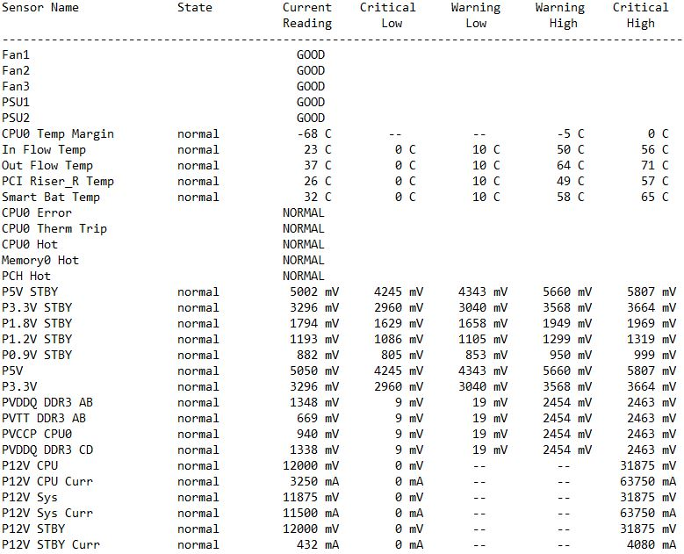**

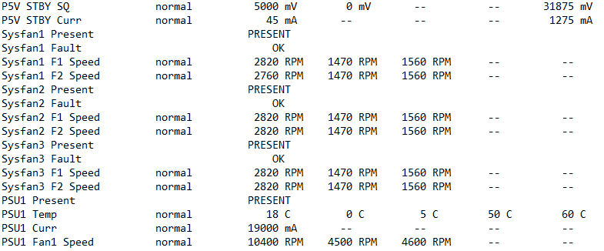

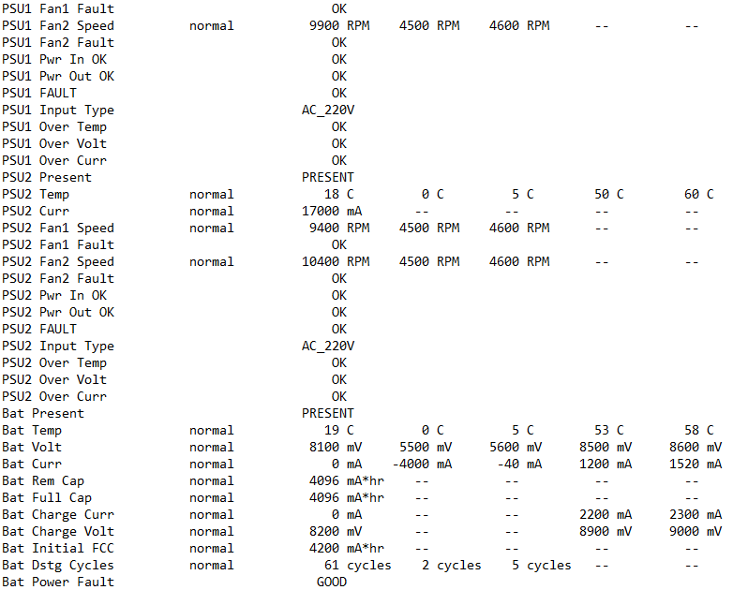

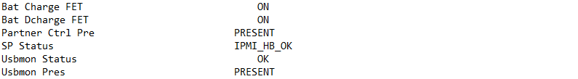

**Gambar di bawah ini refer ke <putty logs> environment status JKT-STOCL-02**

**JKT-STOCL-02**

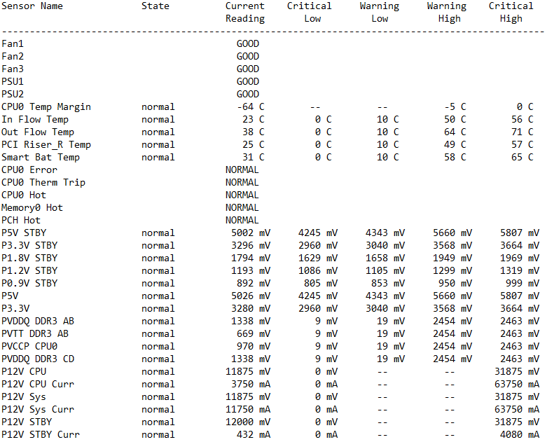

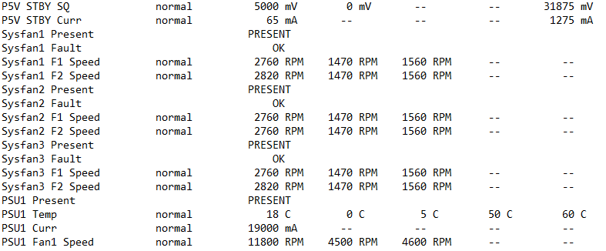

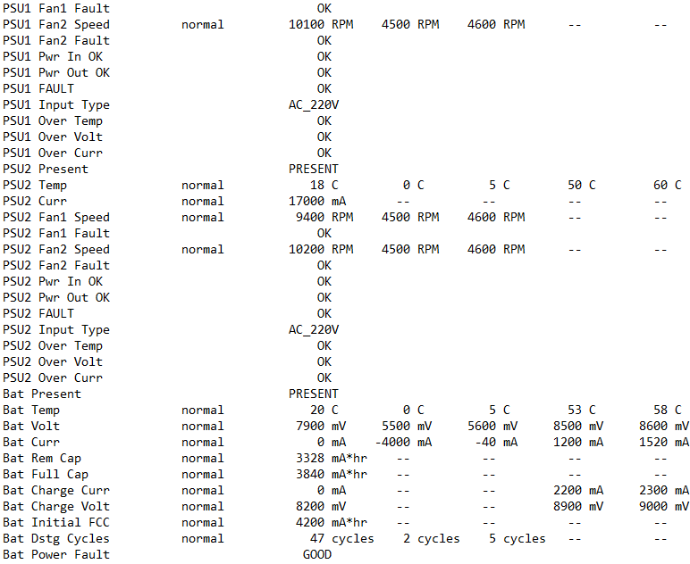

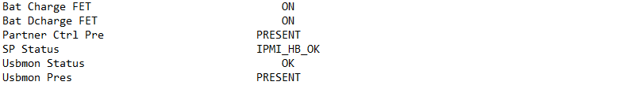

**Gambar di bawah ini refer ke <putty logs> environment status JKT-STOCL-03**

**JKT-STOCL-03**

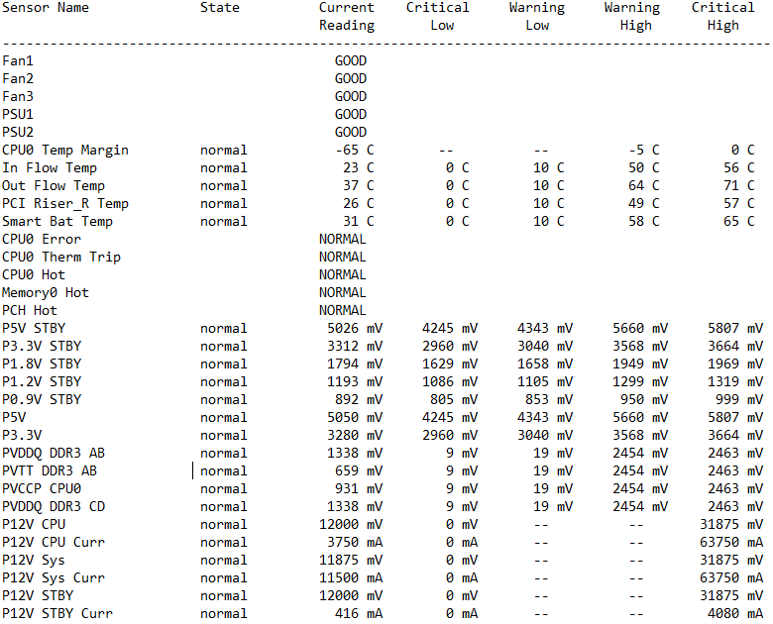

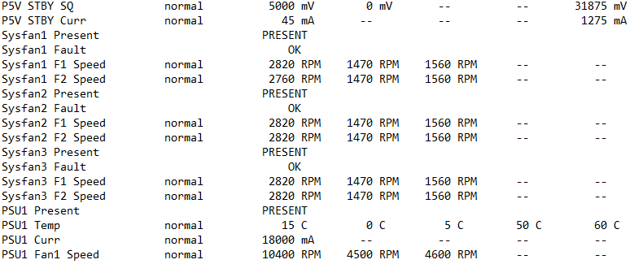

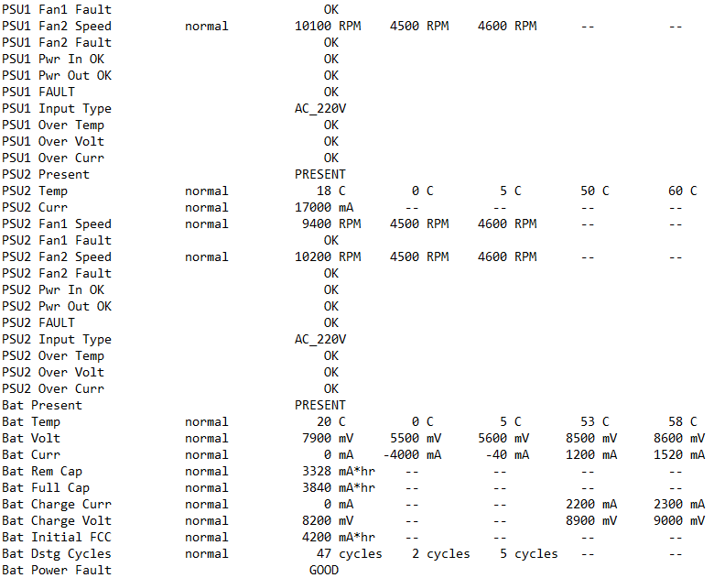

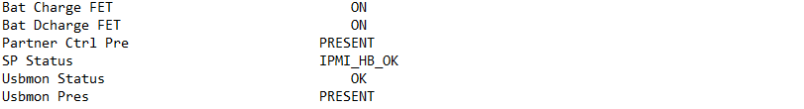

**Gambar di bawah ini refer ke <putty logs> environment status JKT-STOCL-04**

**JKT- STOCL-04**

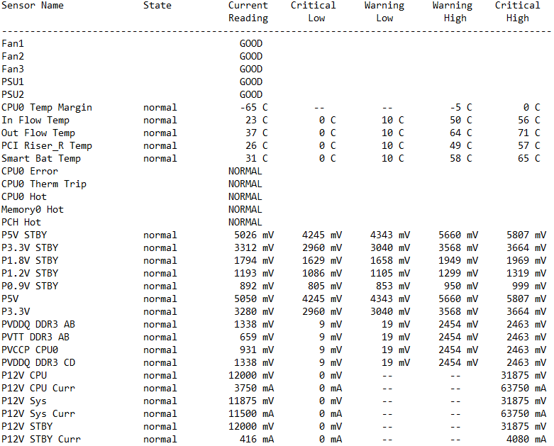

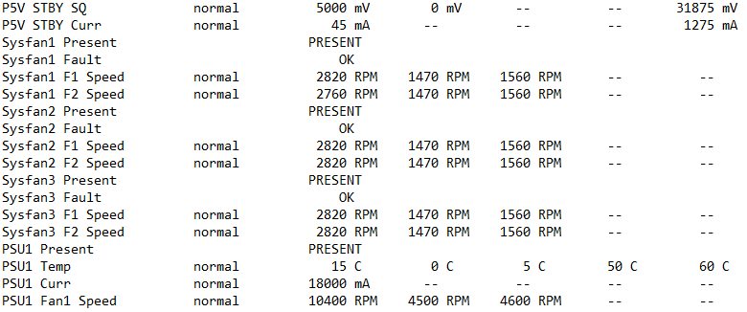

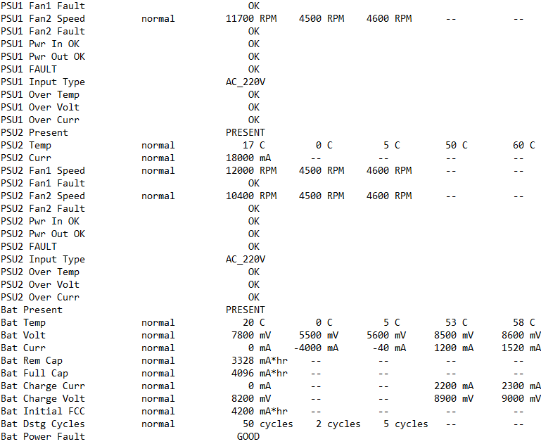

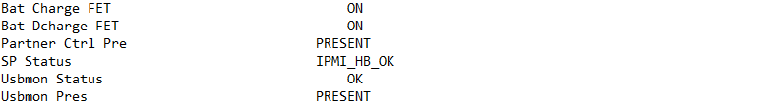

**Gambar di bawah ini refer ke <putty logs> License Show**

1. **License Status**

**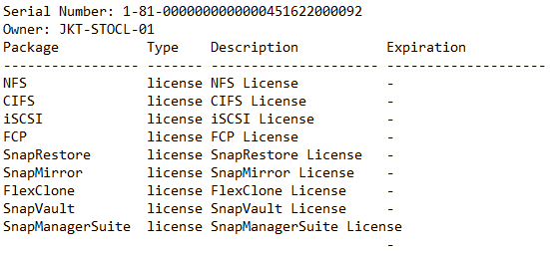**

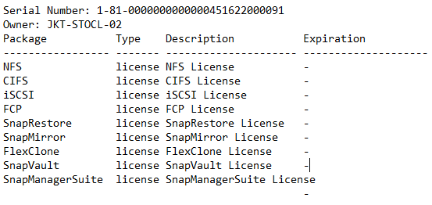

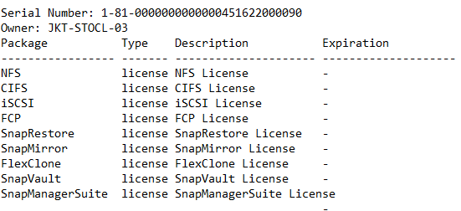

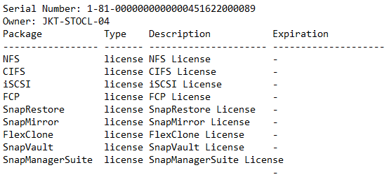

### Netapp FAS8020 HA JAH-STOCL ( DRC Jatiluhur )

**JAH-STOCL-01, Controller A**

Model Name : NetApp Release 9.1P14 Cluster Mode

System Serial Number : 451613000032

System ID : 0536995919 (JAH-STOCL-01)

Partner ID : 0536976712 (JAH-STOCL-02)

Loader Version : 5.5

Processor type : Intel(R) Xeon(R) CPU E5-2620 @ 2.00GHz

Memory Size : 24576 MB

NVRAM : 4096 MB

**JAH-STOCL-02, Controller B**

Version : NetApp Release 9.1P14 Cluster Mode

Model Name : FAS8020

System Serial Number : 451613000031

System ID : 0536976712 (JAH-STOCL-02)

Partner ID : 0536995919 (JAH-STOCL-01)

Loader Version : 5.5

Processor type : Intel(R) Xeon(R) CPU E5-2620 @ 2.00GHz

Memory Size : 24576 MB

NVRAM : 4096 MB

1. **System Dashboard**

**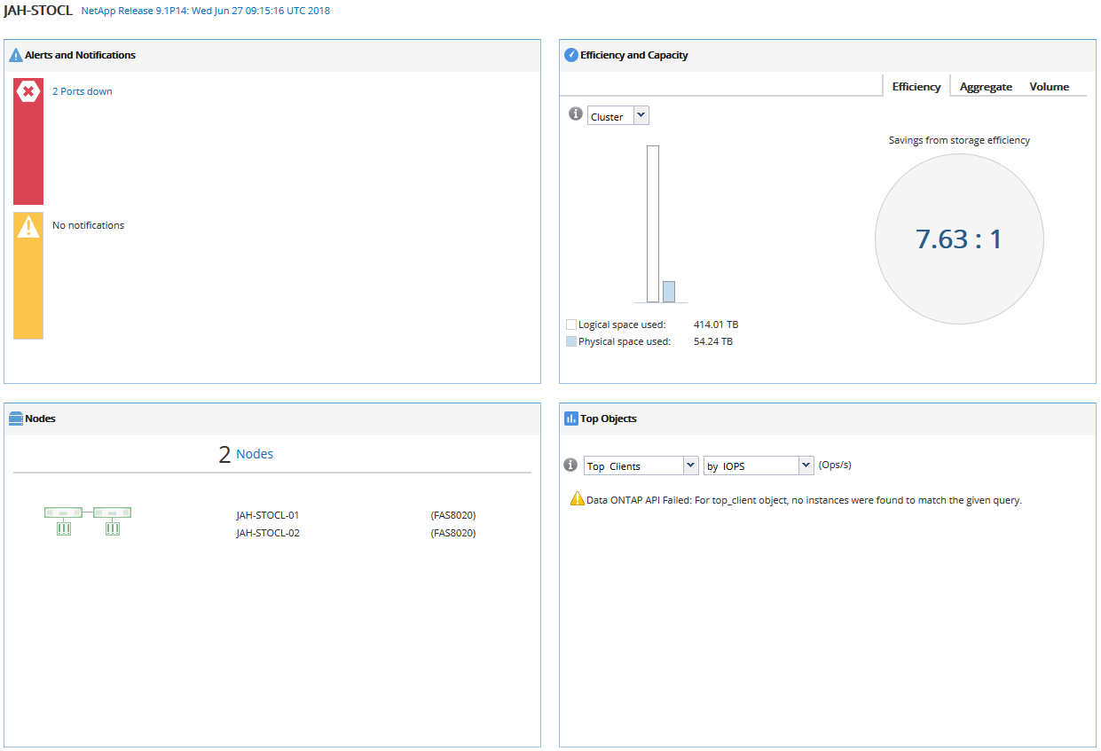**

**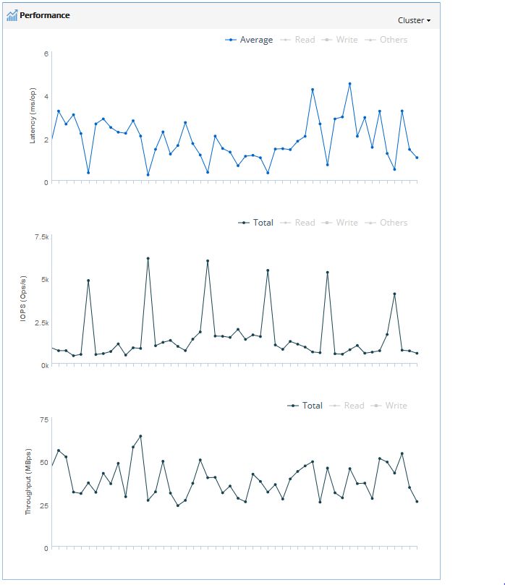**

1. **Storage Capacity**

**Table di bawah refer ke file .xls (C:\Users\WAHIDI\Documents\PM SKK\DRC) PM\_SKK\_DRC\_20190210102129.xls-> Sheet Hardware Overview -> NetApp System Inventory (All Storage Systems - by HA Pair)**

|  |  |  |  |  |  |  |  |
| --- | --- | --- | --- | --- | --- | --- | --- |
| **NetApp System Inventory (All Systems)** | | | |  |  |  |  |
| **Model** | **Hostname** | **Serial Number** | **OS Version** | **Total Capacity (TB)** | **Total Usable Capacity (TB)** | **Total Used Capacity (TB)** | **Total Available Capacity (TB)** |
|  |  |  |  |  |  |  |  |
|  |  |  |  |  |  |  |  |

**JAH-STOCL-01**

**Table di bawah refer ke file .xls (C:\Users\WAHIDI\Documents\PM SKK\DRC) PM\_SKK\_DRC\_20190210102129.xls-> Capacity -> Host Name : JAH-STOCL-01 -> Aggregate Info**

|  |  |  |  |  |  |  |  |
| --- | --- | --- | --- | --- | --- | --- | --- |
| **Aggregate Info** | | | | |  |  |  |
| **Aggregate Name** | **Allocated (TB)** | **Used (TB)** | **Avail (TB)** | **Avail (%)** | **Snap Reserve %** | **Avail in Volumes (GB)** | **Aggregate Type** |
|  |  |  |  |  |  |  |  |
|  |  |  |  |  |  |  |  |

**Table di bawah refer ke file .xls (C:\Users\WAHIDI\Documents\PM SKK\DRC) PM\_SKK\_DRC\_20190210102129.xls-> Capacity -> Host Name : JAH-STOCL-01 -> Disk Summary**

|  |  |  |  |  |  |  |  |  |  |
| --- | --- | --- | --- | --- | --- | --- | --- | --- | --- |
| **Disk Summary** | | | | | |  | |  | |
| **Disk Model** | **Disk Type** | **Disk Mktg Size(GB)** | **# of Owned Disks** | **# of Data Drives** | **# of Parity Drives** | | **# of Spare Disks** | |
|  |  |  |  |  |  | |  | |
|  |  |  |  |  |  | |  | |
|  |  |  |  |  |  | |  | |
|  |  |  |  |  |  | |  | |
|  |  |  |  |  |  | |  | |
|  |  |  |  |  |  | |  | |
|  |  |  |  |  |  | |  | |

**Table di bawah refer ke file .xls (C:\Users\WAHIDI\Documents\PM SKK\DRC) PM\_SKK\_DRC\_20190210102129.xls-> Capacity -> Host Name : JAH-STOCL-02 -> Aggregate Info**

**JAH-STOCL-02**

|  |  |  |  |  |  |  |  |
| --- | --- | --- | --- | --- | --- | --- | --- |
| **Aggregate Info** | | | | |  |  |  |
| **Aggregate Name** | **Allocated (TB)** | **Used (TB)** | **Avail (TB)** | **Avail (%)** | **Snap Reserve %** | **Avail in Volumes (GB)** | **Aggregate Type** |
|  |  |  |  |  |  |  |  |
|  |  |  |  |  |  |  |  |

**Table di bawah refer ke file .xls (C:\Users\WAHIDI\Documents\PM SKK\DRC) PM\_SKK\_DRC\_20190210102129.xls-> Capacity -> Host Name : JAH-STOCL-02 -> Disk Summary**

|  |  |  |  |  |  |  |  |  |  |
| --- | --- | --- | --- | --- | --- | --- | --- | --- | --- |
| **Disk Summary** | | | | | |  | |  | |
| **Disk Model** | **Disk Type** | **Disk Mktg Size(GB)** | **# of Owned Disks** | **# of Data Drives** | **# of Parity Drives** | | **# of Spare Disks** | |
|  |  |  |  |  |  | |  | |
|  |  |  |  |  |  | |  | |
|  |  |  |  |  |  | |  | |
|  |  |  |  |  |  | |  | |
|  |  |  |  |  |  | |  | |
|  |  |  |  |  |  | |  | |
|  |  |  |  |  |  | |  | |

**Table di bawah refer ke file .xls (C:\Users\WAHIDI\Documents\PM SKK\DRC) PM\_SKK\_DRC\_20190210102129.xls-> Capacity -> Volume Info**

1. **Volume Info**

|  |  |  |  |  |  |  |  |
| --- | --- | --- | --- | --- | --- | --- | --- |
|  | | | | |  |  |  |
| **SVM Name** | **Volume Name** | **Allocated** | **Used - Data** | **Used by Snapshots** | **Avail** | **Avail(%)** | **Containing Aggregate** |
|  |  |  |  |  |  |  |  |
|  |  |  |  |  |  |  |  |
|  |  |  |  |  |  |  |  |
|  |  |  |  |  |  |  |  |
|  |  |  |  |  |  |  |  |
|  |  |  |  |  |  |  |  |
|  |  |  |  |  |  |  |  |
|  |  |  |  |  |  |  |  |
|  |  |  |  |  |  |  |  |
|  |  |  |  |  |  |  |  |
|  |  |  |  |  |  |  |  |
|  |  |  |  |  |  |  |  |
|  |  |  |  |  |  |  |  |
|  |  |  |  |  |  |  |  |
|  |  |  |  |  |  |  |  |
|  |  |  |  |  |  |  |  |
|  |  |  |  |  |  |  |  |
|  |  |  |  |  |  |  |  |
|  |  |  |  |  |  |  |  |
|  |  |  |  |  |  |  |  |
|  |  |  |  |  |  |  |  |
|  |  |  |  |  |  |  |  |
|  |  |  |  |  |  |  |  |
|  |  |  |  |  |  |  |  |
|  |  |  |  |  |  |  |  |
|  |  |  |  |  |  |  |  |
|  |  |  |  |  |  |  |  |
|  |  |  |  |  |  |  |  |
|  |  |  |  |  |  |  |  |
|  |  |  |  |  |  |  |  |
|  |  |  |  |  |  |  |  |
|  |  |  |  |  |  |  |  |
|  |  |  |  |  |  |  |  |
|  |  |  |  |  |  |  |  |
|  |  |  |  |  |  |  |  |
|  |  |  |  |  |  |  |  |
|  |  |  |  |  |  |  |  |
|  |  |  |  |  |  |  |  |
|  |  |  |  |  |  |  |  |
|  |  |  |  |  |  |  |  |
|  |  |  |  |  |  |  |  |
|  |  |  |  |  |  |  |  |
|  |  |  |  |  |  |  |  |
|  |  |  |  |  |  |  |  |
|  |  |  |  |  |  |  |  |

**Table di bawah refer ke file .xls (C:\Users\WAHIDI\Documents\PM SKK\DRC) PM\_SKK\_DRC\_20190210102129.xls-> Capacity -> Lun Info**

1. **Lun Info**

|  |  |  |  |
| --- | --- | --- | --- |
|  | | | |
| **SVM Name** | **LUN Name** | **LUN Path** | **LUN Size** |
|  |  |  |  |
|  |  |  |  |
|  |  |  |  |
|  |  |  |  |
|  |  |  |  |
|  |  |  |  |
|  |  |  |  |
|  |  |  |  |
|  |  |  |  |
|  |  |  |  |
|  |  |  |  |
|  |  |  |  |
|  |  |  |  |
|  |  |  |  |
|  |  |  |  |
|  |  |  |  |
|  |  |  |  |
|  |  |  |  |
|  |  |  |  |
|  |  |  |  |
|  |  |  |  |
|  |  |  |  |
|  |  |  |  |
|  |  |  |  |
|  |  |  |  |
|  |  |  |  |
|  |  |  |  |
|  |  |  |  |
|  |  |  |  |
|  |  |  |  |
|  |  |  |  |
|  |  |  |  |
|  |  |  |  |
|  |  |  |  |
|  |  |  |  |
|  |  |  |  |
|  |  |  |  |
|  |  |  |  |
|  |  |  |  |
|  |  |  |  |
|  |  |  |  |
|  |  |  |  |
|  |  |  |  |
|  |  |  |  |
|  |  |  |  |
|  |  |  |  |
|  |  |  |  |
|  |  |  |  |
|  |  |  |  |
|  |  |  |  |
|  |  |  |  |
|  |  |  |  |

**Gambar di bawah ini refer ke <putty logs> environment status JAH-STOCL-01**

1. **Environment Statu**

**JAH-STOCL-01**

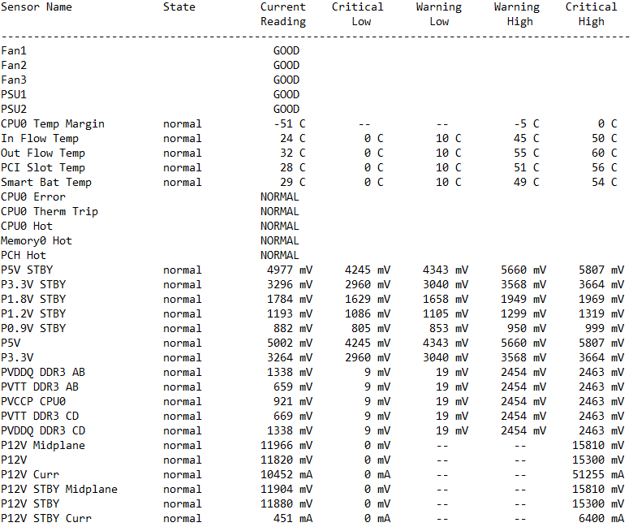

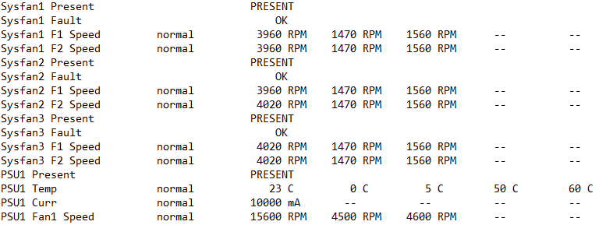

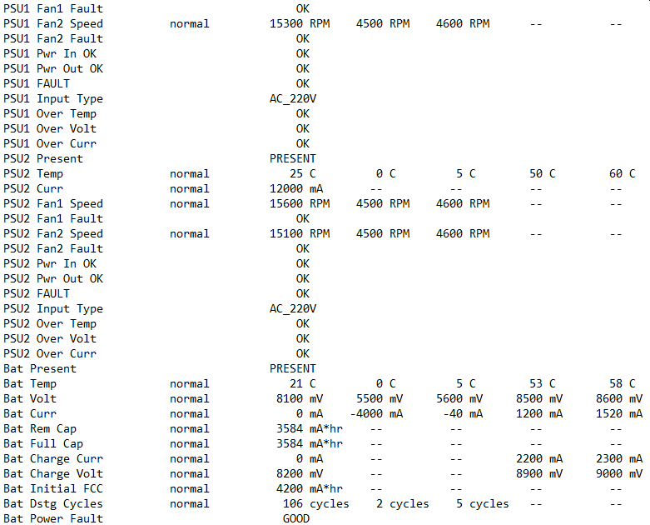

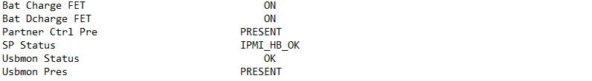

**Gambar di bawah ini refer ke <putty logs> environment status JAH-STOCL-02**

**JAH-STOCL-02**

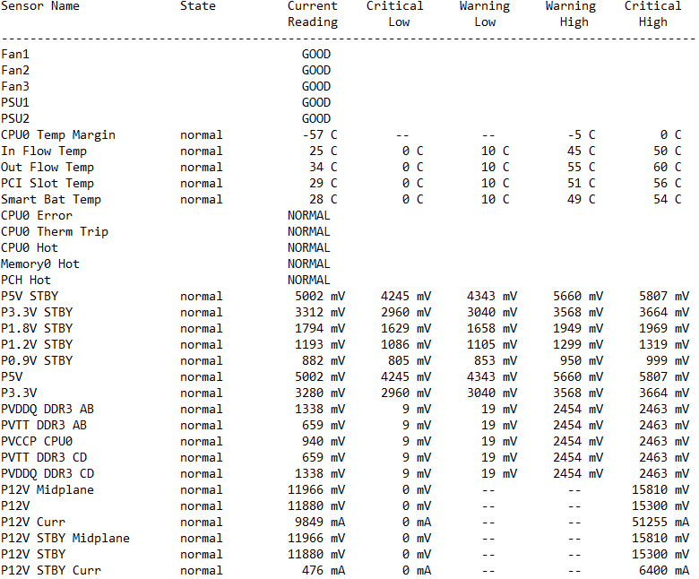

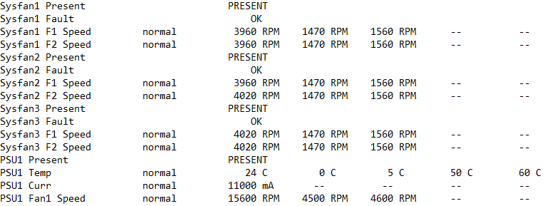

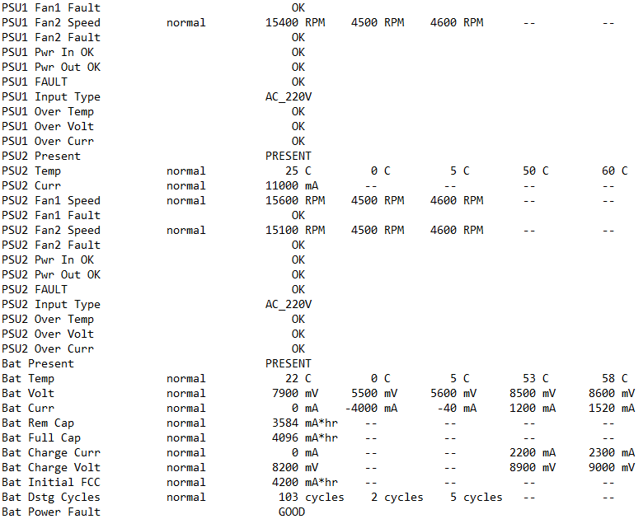

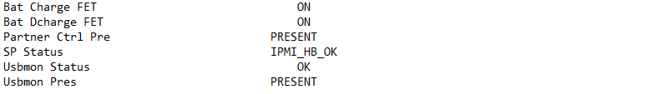

**Gambar di bawah ini refer ke <putty logs> license show**

1. **License Status**

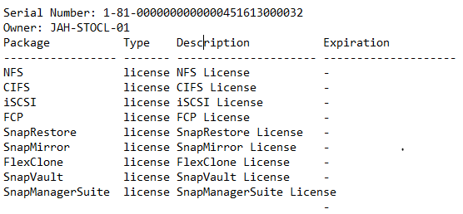

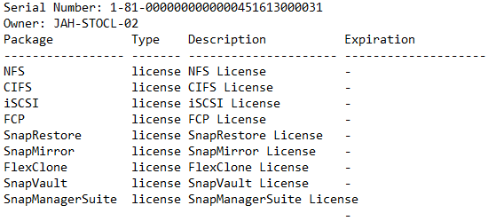

## Kesimpulan dan Saran

### Kesimpulan

* + - 1. Proteksi data tetap terjaga.
      2. Beberapa Volume sudah diatas threshold >90%, Ini mengakibatkan performance dari storage menjadi menurun.
      3. Beberapa schedule dedup tidak jalan di satu atau beberapa volume, dikarenakan change log size sudah 100%, kondisi normal 20% - 80%.

### Saran

* + - 1. Untuk proteksi data, disarankan dijadwalkan pengambilan snapshoot 1 hari sekali dan di simpan 1 hari minimal.
      2. Resizing volume disesuaikan dengan kebutuhan penyimpanan data agar performance penyimpanan data selalu terjaga.
      3. Menjalankan dedupe manual di volume yang bermasalah

( <https://kb.netapp.com/app/answers/answer_view/a_id/1070703> )

# Corrective Maintenance

Di bawah ini akan disampaikan aktifitas-aktifitas Corrective Maintenance yang dilakukan pada periode Januari 2019 <bulan perlu diganti setiap bulan nya>

## Activity Report

|  |  |  |  |  |  |  |  |
| --- | --- | --- | --- | --- | --- | --- | --- |
| **No** | **Ticket** | **Open** | **Close** | **PiC** | **Activity** | **Engineer** | **Solusi** |
| 1 | 2007725418 | 20-12-2018 | 20-12-2018 | Heru Basuki | DSKFLT:Disk 0b.24.18 Shelf 24 Bay 18 | Wahidi | Replacement Disk |
| 2 | 2007732915 | 29-12-2018 | 31-12-2018 | Heru Basuki | DSKFLT:Disk 4c.07.5 Shelf 7 Bay 5 | Wahidi | Replacement Disk |
|  |  |  |  |  |  |  |  |
|  |  |  |  |  |  |  |  |
|  |  |  |  |  |  |  |  |
|  |  |  |  |  |  |  |  |
|  |  |  |  |  |  |  |  |
|  |  |  |  |  |  |  |  |
|  |  |  |  |  |  |  |  |

# Penggantian Part

Pada bagian ini akan disampaikan penggantian part yang telah dilakukan :

|  |  |  |  |  |  |  |  |  |  |
| --- | --- | --- | --- | --- | --- | --- | --- | --- | --- |
| No | Service Date | Hostname | Location | Broken Part | | Replacement Part | | Qty | Description |
| Part Name | S/N | Part Name | S/N |
| 1 | 20-10-2018 | JKT-STOCL-01 | JAKARTA | X412\_S15K7560A15 | 6SL68A2E0000N3411VTF |  |  | 1 | Spare Disk Failed Disk 0b.24.18 Shelf 24 Bay 18 |
| 2 | 29-10-2018 | JKT-STOCL-04 | JAKARTA | X412\_S15K7560A15 | 6SL62E4W0000N3352WLC |  |  | 1 | Disk Failed 4c.07.5 Shelf 7 Bay 5 |
|  |  |  |  |  |  |  |  |  |  |
|  |  |  |  |  |  |  |  |  |  |
|  |  |  |  |  |  |  |  |  |  |
|  |  |  |  |  |  |  |  |  |  |
|  |  |  |  |  |  |  |  |  |  |
|  |  |  |  |  |  |  |  |  |  |
|  |  |  |  |  |  |  |  |  |  |
|  |  |  |  |  |  |  |  |  |  |

# Penutup

Demikianlah laporan pemeliharaan perangkat keras dalam pemenuhan pelaksanaan pekerjaan Perpanjangan Garansi dan Maintenance SAN Storage SKK Migas kami sampaikan, dengan harapan pihak SKK Migas memiliki gambaran terkait dengan aktifitas-aktifitas pemeliharaan yang telah dilakukan guna menjaga kestabilan performa perangkat keras yang menjadi bagian dari pekerjaan ini.

Taklupa pula kami ucapkan terima kasih atas dukungan dan kerjasama dari tim SKK Migas guna memperlancar proses pelaksanaan pekerjaan.